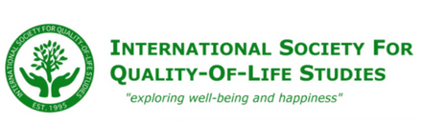  The “ISQOLS Certification in Quality-of-Life Research: Related to Community Indicators Projects” is designed to help QOL researchers specializing in community indicators projects obtain additional training and become officially certified in the field. This certificate program is facilitated by the International Society for Quality-of-Life Studies (ISQOLS) and the Management Institute for Quality of Life Studies. The ISQOLS 2020 Certificate Program Scholarship provides $300.00 USD (50% off) the member rate for up to three qualified applicants.  The certificate scholarship is limited to:  - Professionals in related organizations doing community indicators research,  - Professionals with bachelor’s and master’s degrees, not PhD’s, and  - Professionals in developing countries.  - Current ISQOLS members  Deadline for submission: January 15th, 2020  Please send your completed application below to Jill Johnson at office@isqols.org | ISQOLS 2020  Certificate Program Scholarship Application

Applicant Information
Full Name: |  |  |  |  | Date:
 | Last | First | M.I.

Address:
 | Street Address | Apartment/Unit #

 | Town or City | State (or Province) and Country | Postal Code

Phone: |  | Email

Date of birth: _______________________________________________

Current occupation: _________________________________________

Current Employer: ___________________________________________

Current Employer website: _____________________________________

Please list your academic degrees (please attach a copy of your resume):

Have you paid your 2020 ISQOLS membership dues? If no, why not?

Are you a current professional in a quality-of-life related organization doing community indicators research? Please explain your answer.

Please describe how the scholarship will benefit you:

Deadline for submission: January 15th, 2020
Please send your completed application below to Jill Johnson at office@isqols.org

